MECE-606 Systems Modeling Project

March 3-10, 2016, Rochester, NY, USA

**Single Mass Pendulum**

**Zeyar Win**

Department of Electrical Engineering

Rochester Institute of Technology

Rochester, NY 14623

Email. Zxw6805@rit.edu

**ABSTRACT**

The period, natural frequency and characteristics of pendulum motion can be calculated when the mass of the pendulum, initial position, displacement, and damping coefficient values are known. In this lab project, the damping coefficient, period, natural frequency and other characteristics of pendulum are unknown but only output data are provided. System identification is needed to solve the damping coefficient of the pendulum evaluating 4 cases with and without the mass of a rod consideration. 45 degrees are used as training data set whereas 30 and 90 degrees initial conditions are used as validation data set.

**INTRODUCTION**

The free body diagram of the pendulum can be seen as below.

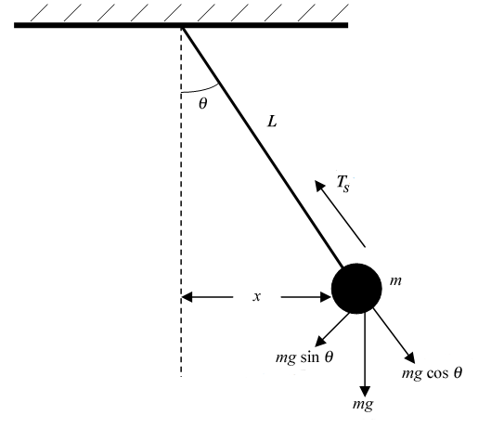

Figure 1. Free body diagram of a pendulum

From free body diagram,

$-T_{d}-Lmgsinθ=mL^{2}θ^{''}$

$-bθ^{'}-Lmgsinθ=mL^{2}θ''$

The equations of motion without and with the mass of rod are as below respectively.

**Guilherme Mollica**

Department of Mechanical Engineering

Rochester Institute of Technology

Rochester, NY 14623

Email. ghg3352@rit.edu

_____(1)

____(2)

where $J_{0}=J_{RG}+m_{r}{\left(\frac{L_{r}}{2}\right)}^{2}+mL^{2}$

$∂=\frac{1}{n}ln(\frac{B_{n}}{B_{n+1}})$___________(3)

$s^{2}+2ζw_{n}s+w_{n}^{2}=0$_____(4)

The equation 3 logarithmic decrement and equation 4 are used to find the natural frequency, damping frequency, period and the length of point mass from a fixed point. After finding period and location of point of mass, damping coefficient value is calculated considering 4 different scenarios.

**ANALYSIS**

The state representation as below is used in Simulink and Matlab to find the damping coefficient.

$θ'=\left[\begin{aligned}0 1 \\ -\frac{g}{L} -b/mL^2 \end{aligned} \right]θ$_________(5)

With the mass of the rod,

$θ'=\left[-\begin{aligned}0 1 \\ \frac{mgL+\frac{mrgL_{r}}{2}}{J_{0}} -b/J_{0} \end{aligned} \right]θ$_____(6)

The coefficient b is the viscous friction with small angles assumption linear model in case 1.The value of b is viscous friction with sin $θ$ in case 2. In case 3, the equation Fd damping force is turbulent flow friction, sign $\left(θ\right)bθ^{'2}$. In case 4, the Fd is combined Coulomb and viscous friction:

$F_{d}=sgn\left(θ^{'}\right)[K_{g}\left|θ^{'}\right|+K_{0}]$. With two unknown values in case 4, the simulation will take more time to estimate the damping factor.

**SIMULATION**

The 4 cases of massless rod are simulated.

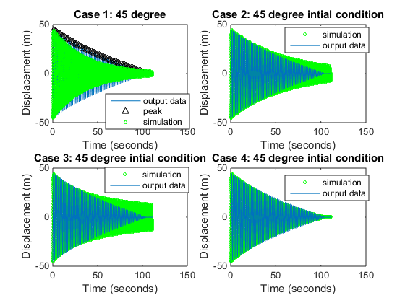

Fig 2.The 45 degree initial condition in 4 cases

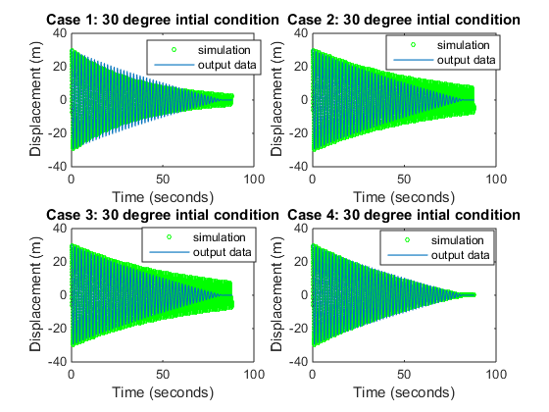

Fig 3 .The 30 degree initial condition in 4 cases

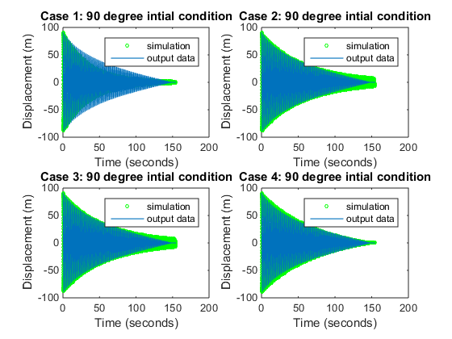

Fig 4.The 90 degree initial condition in 4 cases

It is intriguing to see that case 4 in 90 degree is worse than any other degree cases. Case 2 30 degree has bigger error value when time goes on compared to 90 degree. Small angle approximation is better than sin theta assumption. The one with mass cases fit less than with massless since location of point mass increases by 20 cm due to inertia of the rod.

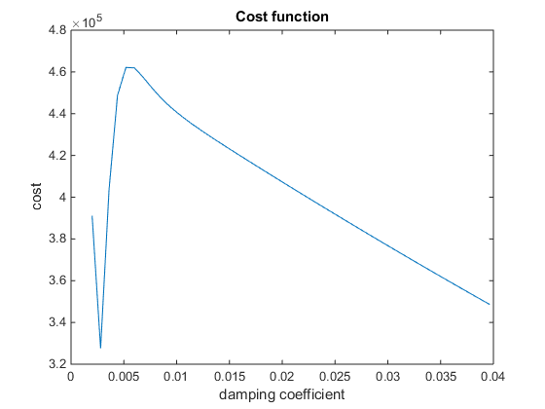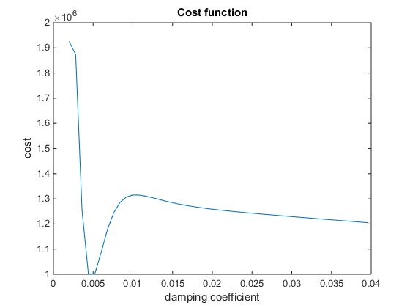

Fig 5.The cost function of case 2 without and with the mass of the rod

The damping constant value is determined using cost function in the Matlab loop. The minimum value is chosen for damping constant. The same principle is applied to 2D arrays as in figure 6.

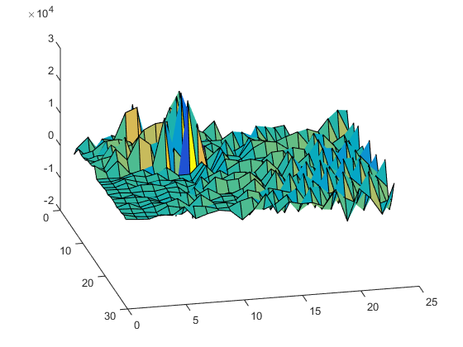

Fig 6. The cost function of number 4 case

The coefficient damping value obtained from 4 different cases in massless rod condition can be seen in the table 1.

|  |  |  |  |
| --- | --- | --- | --- |
| case1 | case2 | case3 | case4(ko/kg) |
| 0.0049 | 0.0028 | 0.0042 | .0019,.002 |

Table 1. Massless rod damping value

The case with rod mass can be observed as in table 2.

|  |  |  |  |  |
| --- | --- | --- | --- | --- |
|  | case1 | case2 | case3 | case4(ko/kg) |
| damping | 0.0105 | 0.0042 | 0.0015 | .0018 , .0026 |
| Jo | 0.1915 | 0.1915 | 0.1915 | 0.1915 |

Table 2. Mass rod damping value

|  |  |  |  |  |
| --- | --- | --- | --- | --- |
|  | case1 | case2 | case3 | case4 |
| RMS45 | 21.1172 | 16.6646 | 16.4339 | 14.7788 |
| RMS30 | 3.3352 | 11.4099 | 11.4099 | 11.8229 |
| RMS90 | 35.0775 | 21.1813 | 21.1813 | 35.1459 |

Table 3: The RMS value for massless rod cases

|  |  |  |  |  |
| --- | --- | --- | --- | --- |
|  | case1 | case2 | case3 | case4 |
| RMS45 | 20.1193 | 17.7439 | 32.2855 | 23.3087 |
| RMS30 | 20.0094 | 14.2035 | 20.9054 | 16.9188 |
| RMS90 | 35.5728 | 36.3516 | 32.0618 | 46.9596 |

Table 4: The RMS value for mass of the rod cases

The RMS Matlab function is used to find the root mean square error of the 24 different situations. Those data can be seen in table 3 and 4.

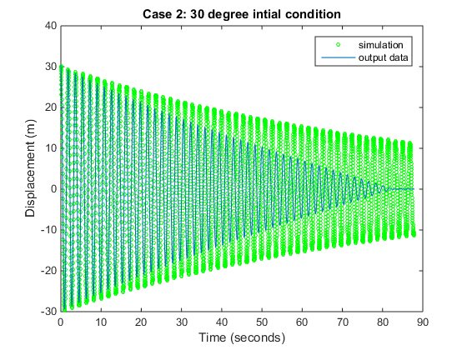

Figure 7. The simulation of pendulum considering mass of the rod with 30’ in case 2

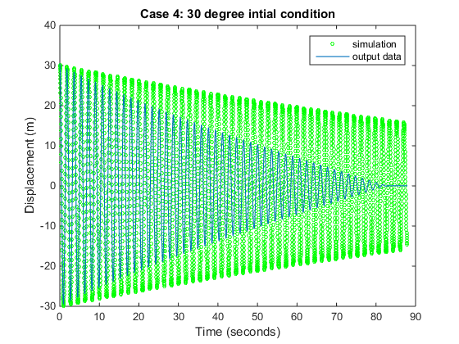 Figure 8. The simulation of pendulum considering mass of the rod with 30’in case 4

**CONCLUSION**

The lab objective was achieved using the equations of motion, finding the approximate value of the damping constant through trial and error, and plotting those using the validation data set. The validation graphs are similar to the original output data samples. It is useful to know that Simulink simulate faster than only execution of Matlab ODE45 function. The ODE45 function was taking hours to simulate. Overall, Matlab is a powerful software to analyze, design and model the systems.